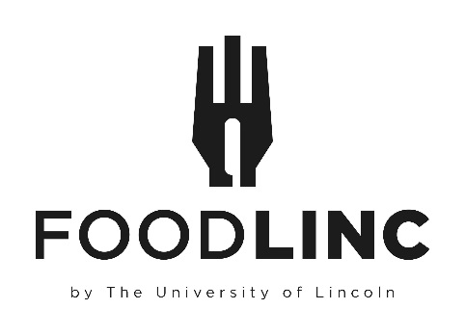

Charlotte Scott Building
Brayford Pool
Lincoln
LN6 7TS

Food Linc Voucher Request

Date of Request

£4.50 Vouchers-Please specify no of books required
(25 vouchers in each book- £112.50 per book)
£2.50 Vouchers-Please specify no of books required
(25 vouchers in each book- £62.50 per book)
£1.80 Vouchers-Please specify no of books required
(25 vouchers in each book- £45.00 per book)
Requestor Name/Contact No.

Budget Holder Approval/ Signature (please print and sign name)
Budget/Cost Centre Codes

TOTAL VALUE TO BE CHARGED

*Vouchers can be collected from Maria Negus. Please phone on ext.6751 to arrange collection from First Floor One Campus Way.

