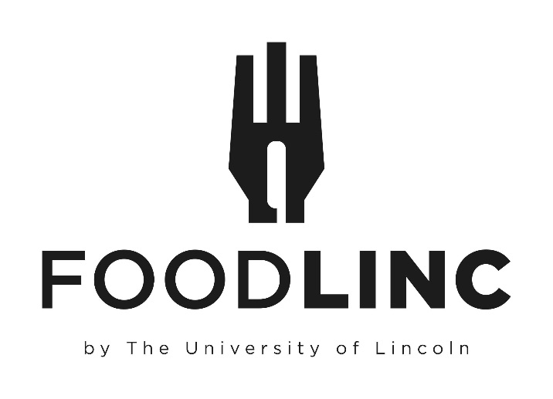

For the full range of Hospitality, we require a minimum of 48 Working Hours’ notice for any new bookings or amendments, except where a larger lead time is otherwise specified
Tables must be booked via Planon on the Estates Support Desk for your requirements
Support Desk – Estates (lincoln.ac.uk)
All bookings are subject to a minimum order value of £35
Bookings maybe subject to a Staffing Surcharge outside of core working hours
Surcharges per person will apply to dietary requests of Vegan and Gluten Free Menu alternatives
Please get in touch with a member of the Hospitality team to discuss options for any dietary requirements required so we can provide alternatives

Index
Buffets
Lindon’s’ Lunch Platter - £8.95
Taste of Lincs’ - £15.00
Traditional Ploughman’s - £11.50
Sweet Treats - £2.25
Hot or Cold Pick & Mix - £ 9.25
Cold Buffet Selection - £20.00
Hot Buffet Selection - £20.00

Miscellaneous
Breakfast Service - From £4.50
Premium Packed Lunch - £7.50
Standard Packed Lunch - £5.25
Grazing Lunch Box - £10.00
Minerva Deli Box - £11.00
Individual Buffet Box - From £12.50
Nibbles and Cheese Board From £5.00
Canapes – From £7.50
Pizza – From £2.00

Refreshments - From £2.50
Alcohol

Lindon’s’ Lunch Platter
£8.95 per person

Selection of Vegetarian, Meat & Fish Sandwiches
Pipers Crisps
A Selection of Fruit Platter & Homemade Cakes
Water

Taste of Lincs’
£15.00 per person

A Selection of Filled Bridge Rolls
Lincolnshire Sausage Rolls with Tomato Relish/Onion Chutney
Homemade Smoked Mackerel Pate with Ciabatta Crostini
Selection of Lincolnshire Cheeses with Homemade Plum Bread and Crackers
Pipers Crisps
Trio of Desserts Including Grantham Ginger Biscuits, Local Honey Cake, Mini Scone and Jam
This offer requires a minimum of 4 working days lead time
Please be aware Vegan Alternatives, if required, may not always be Lincolnshire sourced

Traditional Ploughman’s
£11.50 per person

Pork Pie Selection
Cold Meat Platter
Assorted Cheeses
Pickled Onions & Piccalilli
Baked Crusty Roll & Crackers
Grapes & Celery
Water
This offer requires a minimum of 4 working days lead time

Sweet Treats
£2.25 per person
For a full list of extra Sweet Treats please contact FoodLinc for our current seasonal options

Hot or Cold Pick and Mix Buffet
£9.25 per person

Assorted Mini Wraps (C)
Selection of Sandwiches (C)
Stuffed Potato skins (H)
Mini Sausage rolls (H or C)
Buttermilk Chicken Goujons (H or C)
Mini Quiche (C)
Mini Pie Selection (H)
Pizza Slice (H or C)
Mini vegetable spring roll (H)
Mini duck spring roll (H)
Vegetable Gyoza (H)
Chicken Gyoza (H)
Pork Pie (C)
Savoury Egg (C)
Mozzarella sticks (H)
Sweet Potato Falafel (H or C)
Crispy Camembert (H)
Jalapeno poppers (H)
Moroccan Cauliflower bites (H)
Garlic Mushrooms (H)
Vegetable samosa (H or C)
Meat samosa (H or C)
Onion Bhaji (H or C)
Cheese twists (H or C)
Sundried tomato Bruschetta (C)
Flat Bread and Houmous (C)

Please choose 6 items from the selection above.
These will be served hot or cold as appropriate and will come with a selection of dipping sauces
H- Served Hot
C- Served Cold
H or C- Served Either Hot or Cold, please specify preference

Cold Buffet Selection
£20.00 per person

Please choose three main courses and four salads from the following selections
(For balance we suggest including at least one Vegetarian main course)

Meat Mains
Cold poached salmon supreme with Sweet Thai Dipping Sauce
Cornets of Ham and Roast sirloin of beef with English mustard and Horseradish
Individual Homemade Quiche Lorraine
Seared breast of Chicken marinated in Mediterranean Herbs
Homemade Scotch Egg with Curry Ketchup
Italian Antipasti Platter

Vegetarian Mains
Roast Vegetable Tart
Goat’s cheese, caramelised onion and spinach filo Parcel
Pea and Mint Fritters with Cucumber Raita

Salads
Homemade coleslaw
Pasta and pesto salad
Mixed green salad with balsamic dressing
Tomato mozzarella and basil salad
Beetroot Salad
Luxury Potato Salad
Caesar Salad
Greek salad
Warm Buttered New Potatoes

Accompanied by
Crusty Rolls
Seasonal Desserts available on Booking
Selection of Juice & Water OR Tea & Coffee

Hot Buffet Selection
£20.00 per person

Please choose two main courses from the following selections

Meat Mains

Chicken Chasseur and Creamy Mash
Beef Stroganoff with Basmati Rice
Lamb Hotpot
Luxury Seafood Pie
Beef Bourguignon with Pasta
Thai Green Chicken Curry and Basmati Rice
Lasagne

Vegetarian & Vegan Mains

Mushroom Stroganoff with Wild Rice
Tuscan Bean Bake
Butternut Squash and Sweet Potato Curry with Basmati Rice
Roast Vegetable Lasagne
Vegan Bolognaise and Pasta

All Accompaniments in accordance with Chosen Dish

Finished with

Seasonal Desserts available on Booking
Selection of Juice & Water OR Tea & Coffee

Miscellaneous

Breakfast Service

Choice of hot Bacon, Sausage or Vegetarian Sausage in a white or brown Bread Roll wrapped in foil delivered to your meeting with Juice and sauces
£4.50 per person
£6.50 per person with Tea & Coffee
Selection of Croissants and Danish Pastries with Juice & Water OR Tea and Coffee
£6.00 per person
Chefs Selection of Scones with Butter, Preserves Tea & Coffee
£5.00 per person

Premium Packed Lunch
£7.50 per person

Sandwich, Piece of Fruit, Crisps, Bottle of Water, and a Chocolate Biscuit.

Standard Packed Lunch
£5.25 per person

Sandwich, Crisps, and a Bottle of Water

Minerva Deli Box
£11.00 per person

Individual boxes containing a selection of cured Meats, Olives, Cheese, Chutney, Crackers, Fresh Fruit and Chocolate Thins

Grazing Lunch Box
£10.00 per person

Individual boxes containing a selection of Afternoon Tea style Finger Sandwiches with Popcorn and Pipers Crisps accompanied with a selection of mixed Fruit and bitesize pieces of homemade Flapjack and Chocolate Brownies
Includes a 500ml Water

Individual Buffet Box
£12.50 per person

Individual Buffet Boxes contain a selection of items we all love to have at a party or a picnic. This box contains ¾ savoury and ¼ sweet.
Items may vary slightly, however usually contains a selection of sandwiches, wraps, pork pie, mini quiche, selection of pickles, cheese and crackers. This is balanced with delicious homemade brownie or flapjack and a homemade scone with preserve and clotted cream.
All boxes come with cutlery and a napkin so you can eat anywhere.

£14.50 per person

Includes a packet of Pipers Crisps and a 500ml Water
Nibbles & Cheeseboards

Nibbles
£5.00 per person

Includes a selection of Crudites, Nuts, Crisps and Nachos, Mixed Olives and Accompanying Dips

Cheeseboard
From £6 per person

Includes a selection of Cheeses, Crackers, Grapes, Celery, Apple Wedges and Pickles
A Local Lincolnshire Cheeseboard is available on request

This offer requires a minimum of 4 working days lead time

Canapes’

A selection of Canapes working on 5 items per person.
Choose from

Standard - £7.50 per person

Luxury Homemade - £10.00 person

Pizza’s

12” Pizza
£10.00

Pizza Slice
£2.00

Flavours include Pepperoni, Hawaiian, Vegetable Deluxe, Margarita or Meat Feast
Halal, Gluten Free and Vegan alternative toppings available at a surcharge of £2 per whole pizza
Whole Pizzas can be cut into 6 or 8 slices as required

Refreshments

All drinks will be served in disposables as standard, if you require crockery, please request “Premium Service”.

Tea and Coffee - £2.50
Tea, Coffee & Biscuits - £3.00
Tea, Coffee & Cake - £3.50
Orange or Apple Juice (Jug serves 6) - £3.50
Mineral Waters 500ml Plastic Bottle - £1.10
Mineral Waters 700ml Glass Bottle - £2.75
Mineral Waters 1500ml Plastic Bottle - £3.95
Presse 1000ml Glass Bottle - £5.00

Alcohol

Sale & Return on request only

House Wine
£13 per bottle

Red Shiraz
White Sauvignon Blanc
Rose Blush

Prosecco
£18 per bottle

Beer, Lager & Ales
From £3.50 per bottle

All available on request

Please note, if there is any charge to guests to attend an event where alcohol is served, or they must pay for an alcoholic drink a Temporary Event Notice (TEN) must be applied for.
The cost of a TEN is £21 which will be recharged to you. The council must be given10 working days’ notice excluding day of submission and day of event.
Please contact the Hospitality team to arrange the TEN or discuss if one is required.

