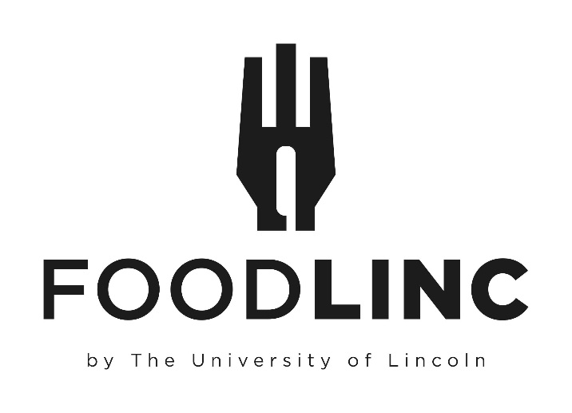
All bookings are subject to a minimum order value of £35
Surcharges of £2/pp will apply to ALL Vegan and Gluten Free requests.
Please get in touch with a member of the Hospitality team to discuss alternative options for any dietary requirements required so we can provide alternatives
We require a minimum of 48 Working Hours’ notice for any new bookings or amendments to your Hospitality requests.
If you require tables for your hospitality, these must be booked via Planon
Support Desk – Estates (lincoln.ac.uk)
A Staffing charge will be applied to any out of normal working hours request.

Buffets
Lindon’s’ Lunch Platter - £9.25
Light Bites - £10.00
Traditional Sharing Ploughman’s - £14.00
Taste of Lincs’ - £15.00
Cold Buffet Selection - £20.00
Hot Home Comforts - £20.00
Sweet Treats - £2.75

Miscellaneous
Refreshments - From £2.50
Grazing Lunch Box - £14.00
Minerva Deli Box - £10.00
Individual Afternoon Tea Box - £12.00
Sharing Boards or Tables - £PAO
Canapes - £12.50

Lindon’s’ Lunch Platter
£9.25 per person
Selection of Vegetarian, Meat & Fish Sandwiches
Pipers Crisps
A Selection of Fruit Platter & Homemade Cakes
Water

Light Bites
£10.00 Per Person

A Selection of Filled Vegetarian, Fish & Meat Bitesize wraps served with a Green Salad and 3 additional compound Salads.

Traditional Sharing Ploughman’s
£14.00 per person
Min No of 10 Covers
Pork Pie Selection
Sausage Rolls
Scotch Eggs
Cold Meats
Assorted Cheeses
Pickles and Chutneys
Baked Crusty Roll & Crackers
Grapes and Celery
Water

Taste Of Lincs’

£15.00 per person

A Selection of Filled Vegetarian, Fish & Meat Wraps
Lincolnshire Sausage Rolls with Tomato Relish/Onion Chutney
Homemade Smoked Mackerel Pate with Ciabatta Crostini
Selection of Lincolnshire Cheeses with Homemade Plum Bread and Crackers
Pipers Crisps
Trio of Desserts Including Grantham Ginger Biscuits, Local Honey Cake, Mini Scone and Jam

Cold Buffet Selection

£20.00 per person

Please choose two main courses and four salads from the following selections

Meat Mains

Cold poached salmon supreme with Sweet Thai Dipping Sauce
Cornets of ham and Roast sirloin of beef with English mustard and Horseradish
Individual Homemade Quiche Lorraine
Seared breast of Chicken marinated in Mediterranean Herbs

Vegetarian Mains

Roast Vegetable Tart
Goat’s cheese, caramelised onion and spinach filo Parcel
Pea and Mint Fritters with Cucumber Raita

Salads

Homemade coleslaw
Pasta and pesto salad
Mixed green salad with balsamic dressing
Tomato mozzarella and basil salad
Beetroot Salad
Luxury Potato Salad
Caesar Salad
Greek salad

Accompanied by
Crusty Rolls
A selection of Cheesecake and Gateau
Selection of Juice & Water OR Tea & Coffee

Hot Home Comforts

£20.00 per person

Please choose two main courses from the following selections

Meat Mains

Chicken Chasseur and Creamy Mash
Beef Stroganoff with Basmati Rice
Lamb Hotpot
Luxury Seafood Pie
Beef Bourguignon with Pasta
Lasagne al Forno

Vegetarian & Vegan Mains

Mushroom Stroganoff with Wild Rice
Tuscan Bean Bake
Butternut Squash and Sweet Potato Curry with Basmati Rice
Roast Vegetable Lasagne
Vegan Bolognaise and Pasta

All Accompaniments in accordance with Chosen Dish

Finished with
A Selection of Cheesecake and Gateau
Selection of Juice & Water OR Tea & Coffee

Sweet Treats
£2.75 Per Person
Can Include.
Local Honey Cake
Decadent Chocolate Brownie
Homemade Scones with Jam & Cream
Plain or Chocolate Flapjack
Cheesecake & Gateau
Seasonal Options
Pieces of Fresh Fruit
Fresh Fruit Platter
Fresh Fruit Salad

Refreshments

All drinks will be served in disposables as standard, if you require crockery, please request “Premium Service”.

Tea and Coffee - £2.75
Tea, Coffee & Biscuits - £3.50
Tea, Coffee & Cake - £3.95
Orange or Apple Juice (Jug serves 6) - £3.50
Mineral Waters 500ml Plastic Bottle - £1.25
Mineral Waters 700ml Glass Bottle - £2.75
Mineral Waters 1500ml Plastic Bottle - £3.95
Presse 750ml Glass Bottle - £5.00

Grazing Lunch Box
£14.00 per person

Individual boxes containing a selection of Afternoon Tea style Finger Sandwiches with Popcorn and Crisps accompanied with a selection of mixed Fruit and bitesize pieces of homemade Flapjack and Chocolate Brownies
Includes a 500ml Water.

Minerva Deli Box
£10.00 per person

Individual Boxes containing a selection of cured meats, olives, cheese, chutney, Crackers, fruit and chocolate.

Individual Afternoon Tea Box
£12.00 per person

Individual Boxes of Traditional Sandwiches and Savoury bites along with a Homemade scone with Jam, Clotted Cream and Butter and Homemade Sweet Treats.

Sharing Boards or Tables

Price Available on Request

Fresh Bread – Olive Oil, Balsamic Vinegar, Sliced Italian Meats, Baked Brie with Rosemary & Garlic,
Olives and Sundried Tomatoes.

Alcohol

Sale & return on request only.

House Wine
£13 per bottle

Red Shiraz
White Sauvignon Blanc
Rose Blush

Prosecco
£18 per bottle

Beer, Lager & Ales
From £3.50 per bottle

All available on request
If you require any other options, please contact us at FoodLinc@lincoln.ac.uk

Please note, if there is any charge to guests to attend an event where alcohol is served, or they must pay for an alcoholic drink a Temporary Event Notice (TEN) must be applied for.
The cost of a TEN is £21 which will be recharged to you. The council must be given10 working days’ notice excluding day of submission and day of event.
Please contact the Hospitality team to arrange the TEN or discuss if one is required.

Canapes’
£12.50 per person

A selection of Homemade Canapes working on 6 pieces per person.
Choose from

COLD

Smoked Salmon & Bream Cheese Bagels

Quail Scotch Egg

Poacher Cheese Gougeres

Insalata Caprese

Beetroot Caviar with Horseradish on Blinis

Goats Cheese and Red Pepper on Quinoa Crisps

Pastrami on Rye with Dill Pickle

Cherry Duck with Balsamic and Pickled Peppers

HOT

Halloumi Fries with Chilli Jam

Fish Cone with Pea Puree

Lincolnshire “Toad in the Hole” with Red Onion Chutney

Thai Fishcake with Sriracha and Garlic Mayonnaise

Sweetcorn Fritter with Tomato Chutney

Black Treacle Glazed Belly Pork

Lamb Kofta with Yoghurt & Mint

Jacket Potato

Regular - £2.00
Sweet - £2.50

Standard Hot Fillings – £1.95

Beans
Chilli
Vegan Chilli

Premium Hot Fillings – £2.95

Cuban Beef
Pulled Teriyaki Chicken
BBQ Pulled Jackfruit

Standard Cold Fillings – £1.75

Grated Cheese
Coleslaw
Tuna

Premium Cold Fillings - £2.50

Coronation Chicken
Cottage Cheese
Caramelised Red Onion and Bacon

If you are looking for something different or bored of Danish pastries at Breakfast, then why not consider the following.

Sweet Potatoes & Sweet Fillings – £5.00

Greek or Natural Yoghurt with
Berries and Honey
Granola and passionfruit
Chocolate and Nut

Hot or Cold Pick and Mix Buffet

£9.25 per person

Please choose 6 items from the list below.
These will be served hot or cold as appropriate and will come with a selection of dipping sauces.
H- Served Hot
C- Served Cold
H or C- Served Either Hot or Cold, please specify preference

Assorted Mini Wraps (C)
Selection of Sandwiches (C)
Stuffed Potato skins (H)
Mini Sausage rolls (H or C)
Buttermilk Chicken Goujons (H or C)
Mini Quiche (C)
Mini Pie Selection (H)
Pizza Slice (H or C)
Mini Vegetable Spring Roll (H)
Mini Duck Spring Roll (H)
Vegetable Gyoza (H)
Chicken Gyoza (H)
Pork Pie (C)
Savoury Egg (C)
Mozzarella Sticks (H)
Sweet Potato Falafel (H or C)
Crispy Camembert (H)
Jalapeno Poppers (H)
Moroccan Cauliflower Sites (H)
Garlic Mushrooms (H)
Vegetable Samosa (H or C)
Meat Samosa (H or C)
Onion Bhaji (H or C)
Cheese Twists (H or C)
Sundried Tomato Bruschetta (C)
Flat Bread and Houmous (C)
Breakfast Service

Choice of hot Bacon, Sausage or Vegetarian Sausage in a white or brown Bread Roll wrapped in foil delivered to your meeting with Juice and sauces.
£4.50 per person
£6.50 per person with Tea & Coffee

Selection of Danish Pastries with Juice & Water OR Tea and Coffee
£6.00 per person

Chefs Selection of Scones with Butter, Preserves Tea & Coffee
£5.00 per person

Premium Packed Lunch
£7.50 per person
Sandwich, Piece of Fruit, Crisps, Bottle of Water and a Chocolate Biscuit.

Standard Packed Lunch
£5.25 per person
Sandwich, Crisps and a Bottle of Water

Pizza’s
12” Pizza
£10.00
Pizza Slice
£2.00
Flavours include Pepperoni, Hawaiian, Vegetable Deluxe, Margarita or Meat Feast
Halal, Gluten Free and Vegan alternative toppings available at a surcharge of £2 per whole pizza
Whole Pizzas can be cut into 6 or 8 slices as required.

